ISRAEL: You’ll Love it from the First SHALOM

April 20 – May 1, 2015 $2599.00 per person (land dbl occupancy)

APR 20 DAY 1: Pack your bags & board your flight from the USA to Tel Aviv. You might use airline mileage, call on your own, or request assistance from Laura.

APR 21 DAY 2: Shalom to Israel. Arrive Ben Gurion Airport near Tel Aviv; our meeting time will be approximately 3 PM. Assistance and transfer to Jerusalem (if you arrive earlier you may transfer on your own to the hotel). Check in to our hotel/home for the next 5 nights. Welcome dinner; meet the group and a briefing on the next few days of activity. Dan Hotel (D)
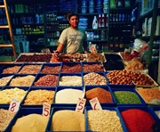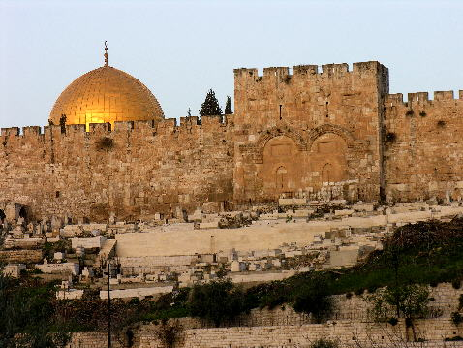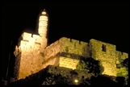
APR 22 DAY 3: An early start today as we will go to the Temple Mount to see the Dome of the Rock and Mosque of Al Aqsa. From here we will proceed into the Old City of Jerusalem entering through one of the many gates leading into the Jewish Quarter and Moslem Shouk. Walk along the Cardo, the colonnaded main street of Byzantine Jerusalem. Learn the history of 3000 years of Jewish presence in Jerusalem and the region. Arrive at the Southern Wall Excavations and Kotel Western Wall. We descend into Rabbinical Tunnel walking adjacent to the lowest level of the Temple Mount. Enjoy the multi-media production giving a colorful overview of Jerusalem's history. Shopping time and a lunch break in the Jewish Quarter and Arab Bazaar. Then, on to the City of David. Walk through the ancient Hezekiah tunnels carved through the stone almost 3000 years ago to store water in emergency cisterns. This evening, a very special treat; we go to David’s Citadel and attend the incredible Sound and Light Show. (B)
APR 23 DAY 4: ISRAEL INDEPENDENCE DAY!! We’ll experience the JOY of Yom Ha’atzmaut first hand!! We begin at the Museum of Theodore Herzl and learn the history of modern Zionism. Continue on to Mount Herzl Military Cemetery; pay respect to Israel's military heroes as well as Prime Ministers Golda Meir and Yitzhak Rabin. Our next stop is Yad Vashem, memorial to the 6 Million. We visit the unforgettable Museum, Hall of Remembrance and Children's Pavilion. Drive via the Supreme Court Building and the Knesset (Parliament) to the Israel Museum to visit the Shrine of the Book, home of the Dead Sea Scrolls. See the Scale Model of Jerusalem, showing the city during the Herodian period (Second Temple). Visit the Machane Yehuda market and enjoy the frenzy of sights, smells and tastes of this world famous market. Shop or wander on your own. Then return to the hotel. (B)

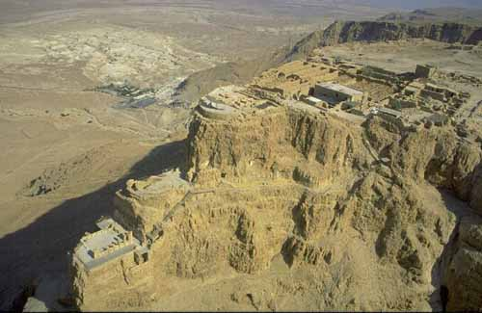APR 24 DAY 5: Drive south from Jerusalem to Gush Etzion. We visit the museum and learn the poignant history of the Gush Etzion Kibbutz dating from the 1920’s. We will drive to the unique Caliber 3 Anti-terrorist training Center for a most interesting and interactive experience. Next, we stop at Herodian and visit the recently excavated Tomb of King Herod. Return to Jerusalem late in the day and prepare for the Sabbath. We’ll go to the Kotel and participate with thousands of people as Shabbat is welcomed. Return to the hotel for candle lighting and
Shabbat dinner and an evening to relax. (B, D)
APR 25 DAY 6: Southeast today through the wilderness of the Judean Desert to the lowest spot on earth, the Dead Sea. The “Sea Level” sign enroute is a fabulous photo op for everyone. Travel along the shoreline and arrive at Masada, the mountain fortress built as a summer palace by Herod. Here the Jewish Zealots fought against mighty Rome 2000 years ago. Ride the cable car to the top and tour Herod's Palace, the Synagogue and Bathhouse. We pass Qumran, discovery site of the Dead Sea Scrolls, and following lunch access the Dead Sea for a Float-Swim. We may also stop at Ein Gedi to enjoy a refreshing dip in the cool mountain spring water. On our return to Jerusalem, drive to the Mount of Olives for the panoramic view of the city. Our guide will point out highlights of some of the places that we have seen already during our journey. (B)
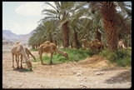
APR 26 DAY 7: Depart Jerusalem traveling east and north via the Jericho Road, passing in the distance, the oldest city in the world. Drive through the Jordan Valley and see firsthand, the safety fence separating Israel from the Palestinian territory. Traveling along the Jordan River we’ll stop and view the Baptismal site relevant for Christians. Watch as the Judean Desert begins to flow into the greenery of Samaria. Arrive at Bet She’an and tour the Scythe city dating back 1800 years. Continue to Beit Alfa and see the ancient synagogue and its’ famous zodiac mosaic. Drive along the shoreline of the Kinneret (Sea of Galilee) to the Kibbutz Ein Gev, home for the next 2 nights. (B, D)

APR 27 DAY 8: Start our day with an exciting ride through the rugged hills of the Golan Heights and a visit to Tel Dan. Stop at a former Syrian fortification. View the Hula Valley below and climb into the relics of Syrian Tanks. We continue to the Crusader’s Nimrod Fortress for an interesting tour of the ruins, and then to Katzrin, capital of the Golan. We’ll stop at a winery to learn about the ideal conditions to cultivate the grapes & olives and we have an opportunity to taste the well-regarded world renowned wines coming from this Golan region. Continue touring the Golan Heights as we ascend Har Ben Tal for a view beyond the border into Syria. Stop at the Kibbutz Naot factory store. You might purchase a pair or 2 of the famous sandals. Wind our way back to the Kibbutz for overnight (B, D)
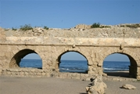
APR 28 DAY 9: Good bye to our Kibbutz and travel to S’fat, 16th century birthplace of the mystical "Kabala" movement. Walk the cobbled streets, visiting the 500 year old synagogues and galleries in the quaint Artists' Colony. Enjoy a bit of shopping on the Artist Street. Driving west, we approach Megiddo, and visit the ancient ruins and the famous water tunnel. Continue through to the upscale city of Caesarea and the port built by Herod 2000 years ago. See the multi media presentation and then visit the Hippodrome and Theater in use today for concerts and plays. Arrive Tel Aviv, Dan Panorama Hotel for 3 nights. Wander on your own along the beach walk, people watch and sit for a coffee. (B)

APR 29 DAY 10: Tel Aviv touring starts with a visit to the Palmach Museum. Learn about the rebirth of the State of Israel and the beginnings of the modern Israel Defense Force. We continue to Independence Hall. Ben Gurion proclaimed Israel's Independence in 1948 from this building. We’ll walk into Jaffa one of the oldest port cities of the Mediterranean and enjoy a tour through the magnificently restored town. Time to stop for lunch and shopping. Touring continues through Tel Aviv and will include the Rabin Memorial and Dizengoff Street. (B)

APR 30 DAY 11: Driving south we arrive at Machon Ayalon for a tour of the secret bullet factory & fascinating glimpse into the activities of the organization known as the Hagannah, the early Israel Defense Force. On to Beit Guvrin to explore some interesting caves, possibly used during the Bar Kochba revolt .Return via the Latrun road for a stop at the Tank Corp Museum, Yad Lashiryon. There are over 100 different types of tanks at this museum. Enjoy an unforgettable opportunity as you climb on board and have a great photo op!! (B)
May 1 DAY 12: A leisure day to enjoy the beach or the hotel pool. Be sure to visit the Carmel Market. Watch the hustle bustle as everyone prepares for Shabbat. Adjacent is the Nahalat Binyamin Art Fair open on Fridays. Here you will find beautiful jewelry, collectibles, clothing and unique pieces all made by local Israeli artists. We will depart the hotel together and enjoy a wonderful farewell dinner. Continue to the airport for return flights to the USA. Return flights should be scheduled for 10 PM or later (El Al & Delta depart just after midnight, May 2) (B, D)
TOUR INCLUDES:
- accommodations at superior hotels & kibbutz guest house
- Israeli Buffet Breakfast (B) daily & 5 additional dinners (D)
- 9 days sightseeing: admissions detailed in itinerary are included
- English speaking licensed guide/fully air-conditioned bus

Transfers to and from airport based on suggested flight times
- Porterage of 1 full size bag per person at hotels/airport
Valid Passport Required (if it is not a US passport contact me)
Tips to guide, bus driver and hotel staff are additional

FOR MORE INFORMATION CONTACT:

Laura Green…TWL EMPRESS,LTD-TOUR ISRAEL NOW

WWW.TOURISRAELNOW.COM

TourIsraelNow@earthlink.net 801-944-5200 office
Deposit of $250.00 per person will hold your space

Final Payment will be due Feb 20, 2015 (refundable up to Jan 1, 2015)
________________________________________________________________________________

NAME________________________________ROOMMATE_________________________________

ADDRESS_________________________________________________________________________

PHONE_____________________________________ EMAIL________________________________

DEPOSIT CHECK ENCLOSED ($250.00 per person)________ VISA/MasterCard accepted (add 2%)

YES I’m interested in cancellation insurance______ YES I need assistance booking air__________

Passport Number___________________________ Expiration date____________________________

Check payable to TWL Empress, LTD. Mail to Laura Green; 10368 South Bedrock Lane; Sandy UT 84092

